P.O. Box 1056 (1 Grant Street)

**PORT MACQUARIE PUBLIC SCHOOL**

**port macquarie COLOUR logo**PORT MACQUARIE NSW 2444

Telephone: (02) 6583 2977

Email: [portmac-p.school@det.nsw.edu.au](mailto:portmac-p.school@det.nsw.edu.au)

Website: www.portmac-p.schools.nsw.edu.au

WELLBEING MANAGEMENT PLAN

During this year the Wellbeing Management Plan will be in place in all classes. We ask for your support and co-operation by discussing this program with your child. The aim of this program is to develop and maintain more productive learning time in the classroom. It is based on a series of positive rewards for appropriate behaviour, combined with consequences for inappropriate behaviour which are enforced if any student reduces the quality of this learning time. The strategies are also aimed at enhancing our playground environment. These strategies and consequences are uniform across the school.

All classes follow the following Five Fair Rules.

***5***

***I control what I do and say***

***4***

***I work quietly***

***3***

***I use my hand and wait***

***2***

***I listen***

***1***

***I follow instructions***

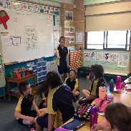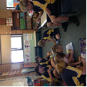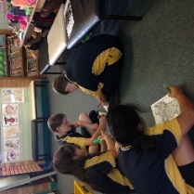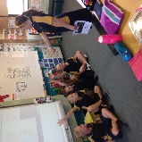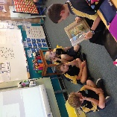

The flow charts on the following page explain how the program operates both in the classroom and in the playground.

You will be contacted if your child is unable to make a change to their behaviour to comply with expectations. In cases of severe insolence or an action that endangers others or property, your child will be immediately excluded from the class and playground and referred to the principal or their supervisor and you will be contacted.

Individual behaviour plans are developed for children who need additional assistance to follow the program.

The program has been developed in conjunction with your child, their peers and teachers. Please discuss these rules, rewards and procedures with your child. If you wish to discuss this plan further, please make an appointment with your class teacher.

At the beginning of the year, students and their teachers discussed and brainstormed the behaviours that they deemed were:

* Positive- Green behaviours e.g. helping others, working quietly etc
* Inappropriate- Orange behaviours e.g. calling out, not following instructions etc
* Diagram, schematic

  Description automatically generatedHigh level unacceptable- Red behaviours e.g. physical violence, swearing etc

Values Vouchers

Our School Values are: Respect, Responsibility, Co-operation and Safety. Students who are demonstrating these values are recognised with a ‘Values Voucher’. These vouchers are collected throughout the week and on a Friday one voucher per stage is drawn at our morning assembly. The winning students are acknowledged with a certificate and a voucher to spend at the school canteen. All Values Vouchers are returned to students after the draw to take home and share with their families.

Highway Hero Vouchers

These vouchers recognise students who are using their Highway Heroes strategies.

Individual Rewards

All classes have an individual behaviour reward system within their classroom. As ‘Green’ positive behaviours are observed throughout the day students are rewarded using this system. These accumulate to earn a Principal’s Award that is given at Stage Assemblies.

Exemplary work and attitude to school will also be rewarded at Stage Assemblies with Merit Certificates.

Class Rewards

Class rewards for ‘collective’ good behaviour vary from class to class as they are negotiated with the children by the class teacher and are open to revision where it is found necessary.

Playground Rewards

Positive behaviour on the playground is rewarded with special ‘Big Day Out’ activities each term. Only those children who always display appropriate behaviour on the playground and who always make correct behaviour choices participate in these activities.

.